VIZ1 Exercises 2

Exercise 1.5 – Bind the Data
- Apply data binding to the <rect> elements of the project
- Print the result using console.log. Inspect it in the console.
- If time permits, create appropriate scales and visualize some data

Exercise 2.1 – Planning the layout
We want to create a bar chart that follows this layout:
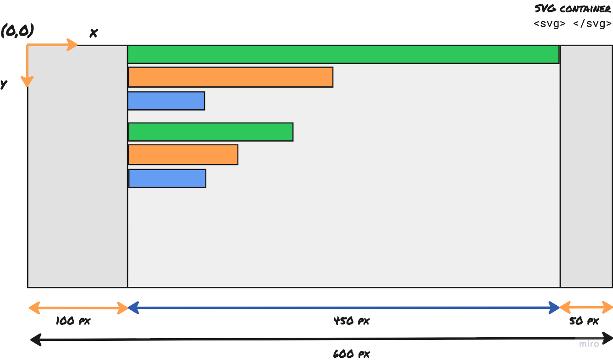
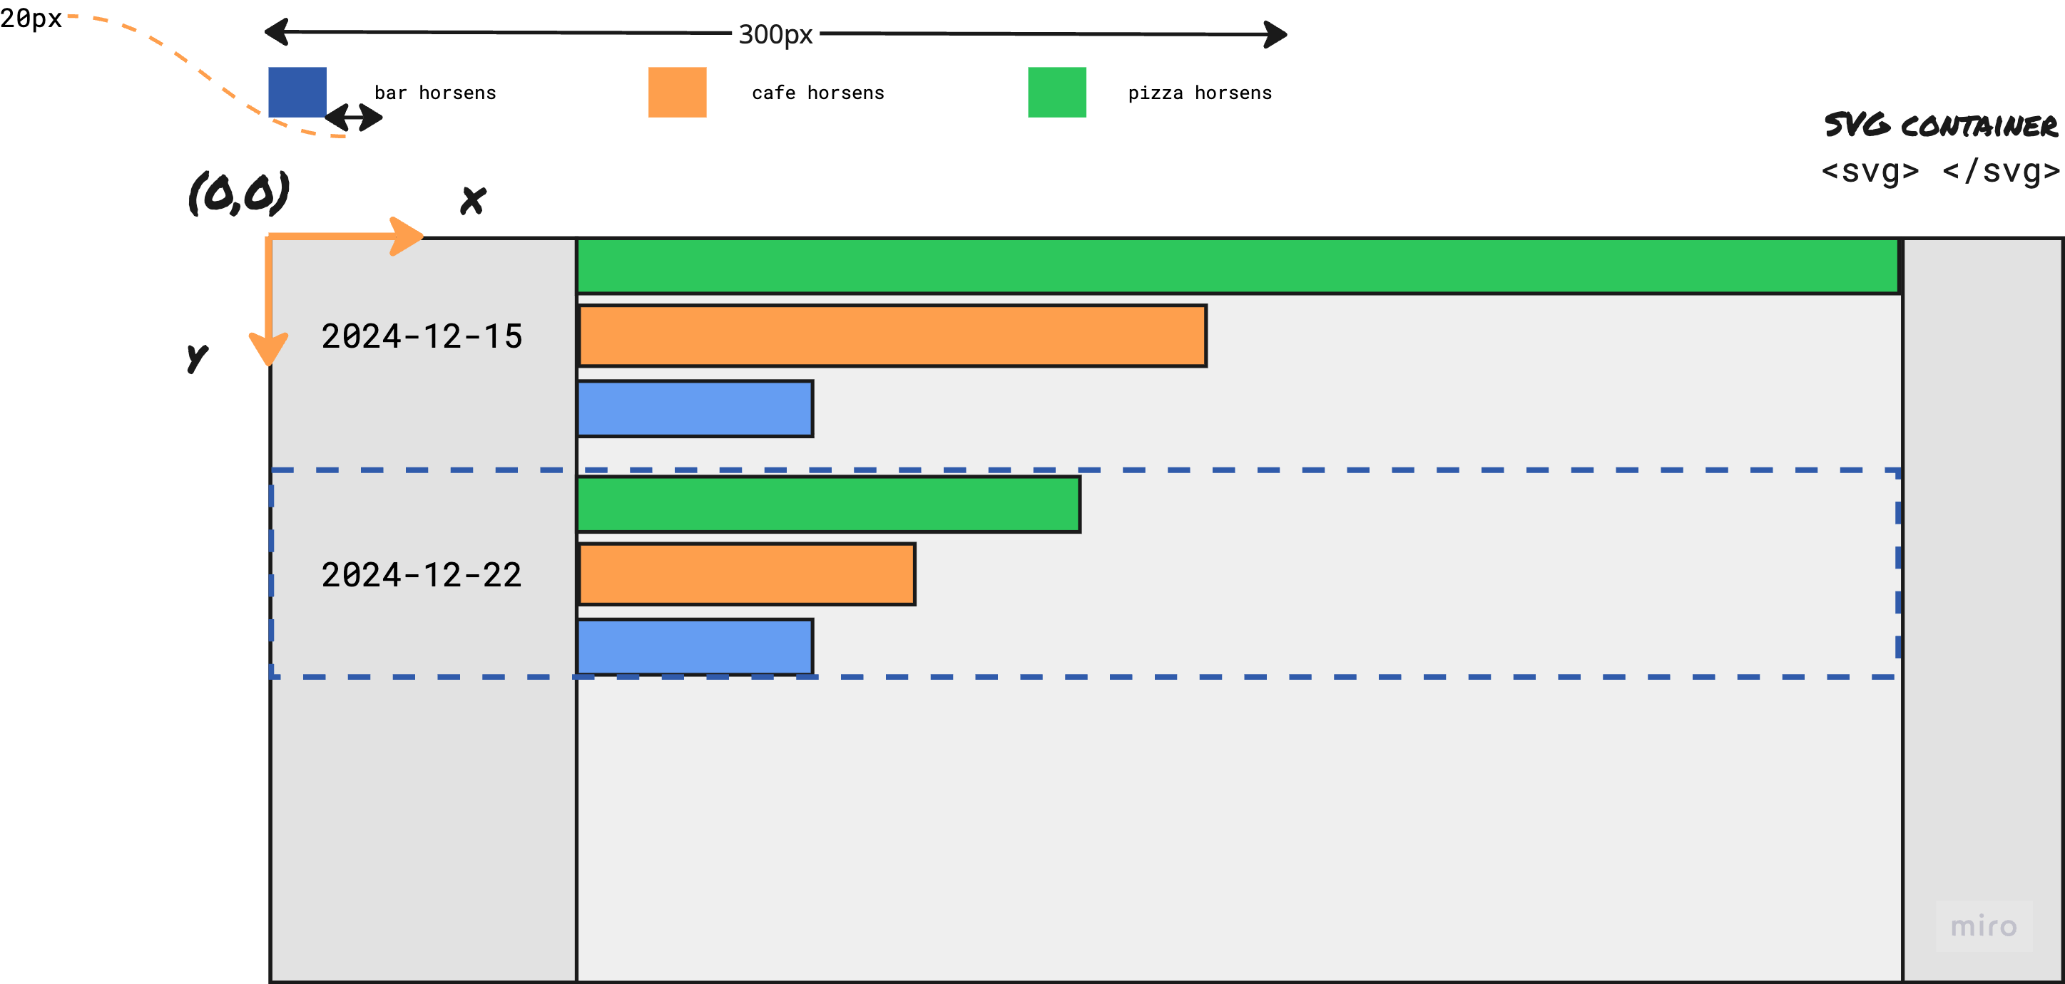

- How would you create the bars using scales?
- How would you position the labels using scales?
- How would you use groups (<g>) to create the legend? Draw it before continuing.

Exercise 2.2 – Implementing the layout
Implement the layout you designed above in D3.js. Take small steps to avoid getting overwhelmed.
The colors used are #1f77b4, #ff7f0e, and #2ca02c

Exercise 2.3 – Discover trends
How would you design a visualization to discover trends in the Google Trends data? It’s up to you to decide which trends you would like to discover.

